**Spark Tool**

**Abigail Hayes-Johnston**

IGNITE

Table of Contents

Introduction 2

What is Ignite? 2

Development Timeline 2

11/09/2017 – 29th/09/2017 2

02/10/2017 – 20/10/2017 3

23/10/2017 – 10/11/2017 3

13/10/2017 – 24/10/2017 3

Design 3

Technical Report 3

Stack-type 3

HTML and CSS 4

JavaScript 4

# Introduction

This document contains all the relevant information surrounding the Tool. It contains the business need along with the technical specifications and suggestions on continuing development with the software.

## What is Ignite?

Ignite is a corporate tool that is in development for the Spark team. It was created to solve a business problem. The problem they were having was that they have very useful change management/business change resources and information, that would be very useful for themselves and their customers to use – but they are located in different places. It was hard to navigate to their various areas and find the information they needed. Another want from the software was some sort of self-help section where customers can answer questions about a change they are managing at the moment and receive tips and relevant tools/techniques to look into. Ignite is therefore a first step for colleagues managing change and reduce a heavy workload for spark and some of their customers could help themselves and do the first stage individually and then if further help is needed spark can be contacted.

## Development Timeline

### 11/09/2017 – 29th/09/2017

* Problem investigation
* Stakeholder assignment
* Courses to assist with content e.g. Prosci, 10 Steps, effective communication.
* HTML, CSS and JavaScript online courses

### 02/10/2017 – 20/10/2017

* Prototype pages
* Check and agree designs
* Begin development
* Front-end Development
* Investigate accessibility issues
* Meet and update stakeholders
* Learn about back-end development
* Investigate internally hosting the tool

### 23/10/2017 – 10/11/2017

* Start back-end development
* Develop database
* Learn how to link database
* Link database
* Develop method to add new tool
* Develop method to delete tool
* Implement admin permissions

### 13/10/2017 – 24/10/2017

* Investigate internal tool maintenance
* Apply for development environment
* Show stakeholders
* Prepare open-day for non-stakeholders with an interest
* Prepare hand-over document
* Wrap-up placement

# Design

I used a materialize/material design due to its clean simple design. It is becoming more popular externally and internally. It is modern looking and displays information in a card structure which worked well for the content of this page.

This design decision was well liked by the stakeholders. I also checked it with creative services who also approved the decision and asked the accessibility lead who said that also long as the guidelines were followed the accessibility of material design would work well.

# Technical Report

## Stack-type

To create the web based software, I opted for the use of a LAMP stack. This means that I used the Linux operating system, and Apache server, a MySQL database and PHP to link the database to the html, css and JavaScript. The reasoning for this was I went with the methods I had the most experience with. I had minimal experience with MySQL and PHP but in contrast had no experience with the alternative database method of Mongo. DB. Due to the limited time pressures I believe using the LAMP stack was one of the reasons it was able to be completed to the stage it is currently at.

## HTML and CSS

The HTML was the basics of what is actually displayed on each of the pages, for example the headings and the paragraphs. It is the basic structure of the pages that can then be edited expanded upon. The CSS then changes the format of the basic HTML. It changes the colour and styling of the various elements.

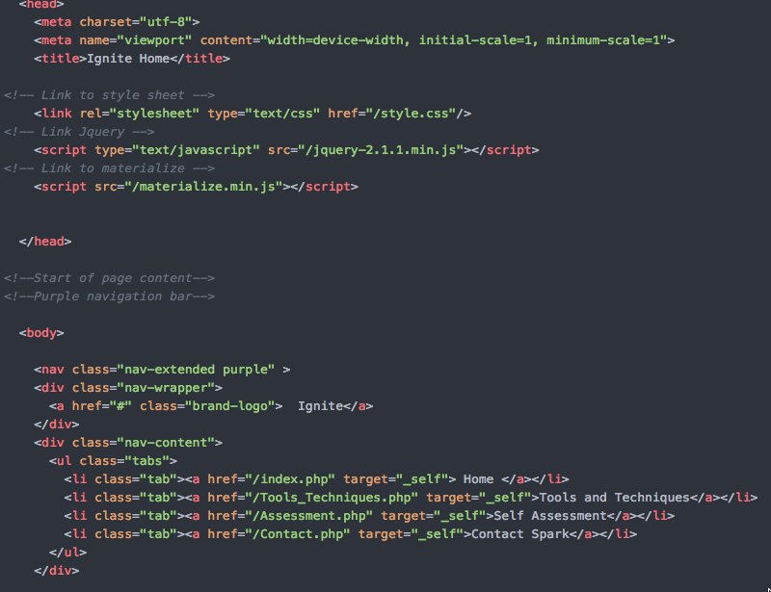

Figure 1 - HTML

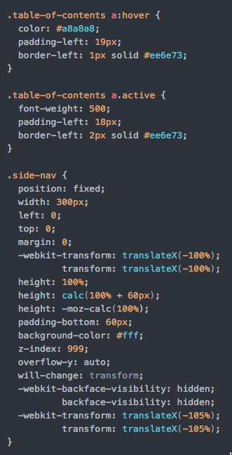

Figure 2 - CSS

## JavaScript

When it came to the JavaScript I used JQuery as it provided the appropriate functionality with the Web application. I was able to implement features such as Image slides and modals. This gave a more interactive element to the tool which was important to my Stakeholders.

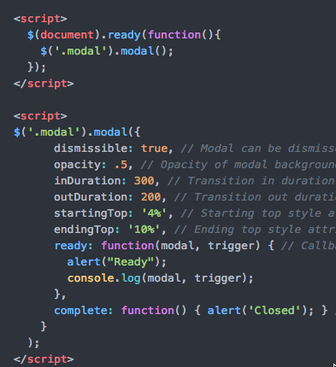

Figure 3 – JavaScript

## MySQL

As the database structure required limited number of tables a MySQL database would fit the requirements. I created a database and that made a schema to create the tables. There are two tables, one is for Tools and Techniques and one is for the Resources. There was a foreign key implemented in the Tools table that linked both the tables.

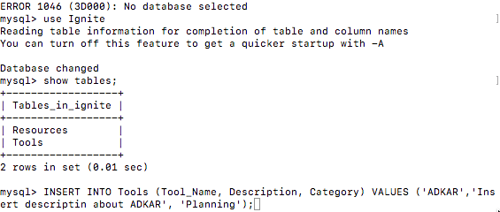

## PHP

I used PHP to link the HTML to the database. This allows the data from the database to be implemented to the page.